HLC TAREA 4B

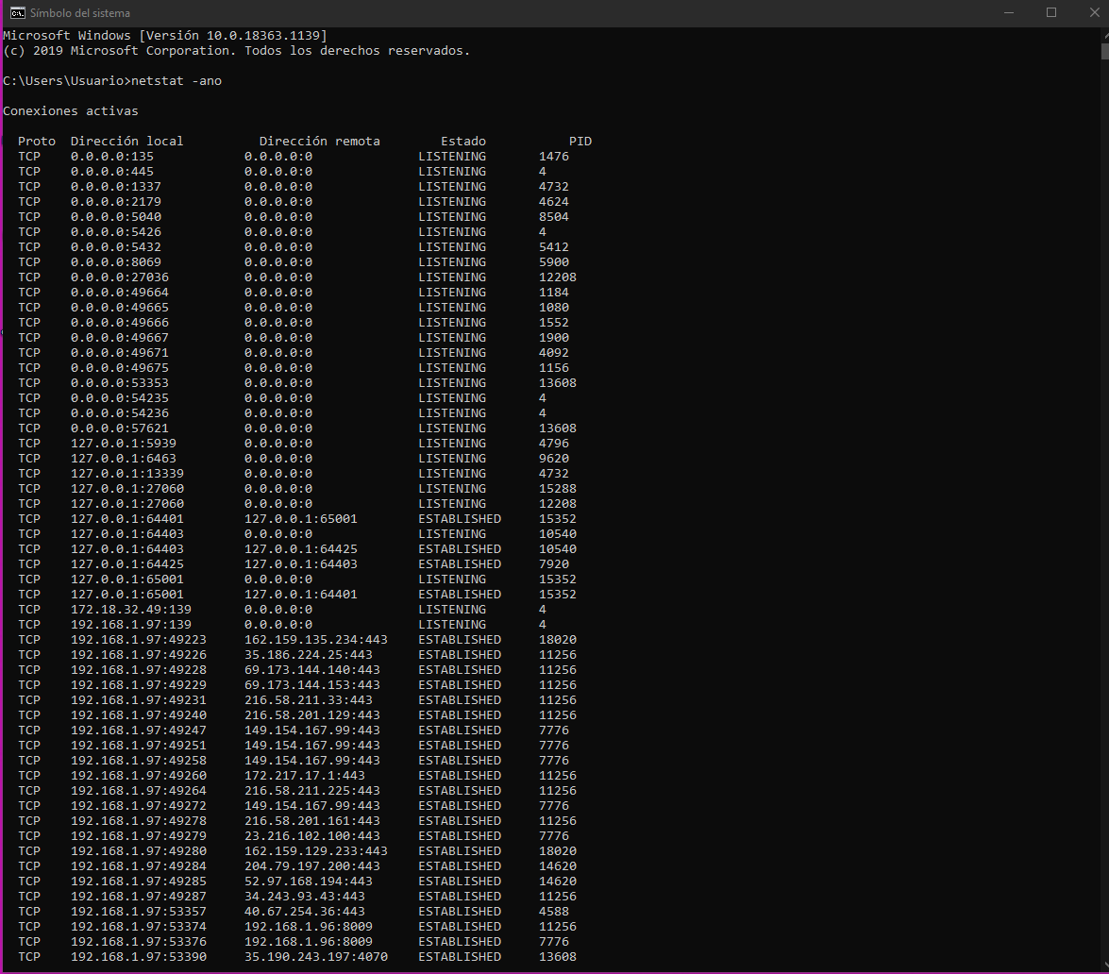
1- En la consola de windows y escribimos “netstat -ano” y nos aparecen las conexiones activas:

2- Observamos el PID de esas conexiones y nos fijamos en donde ponga “ESTABLISHED”, yo he apuntado la información de todos los que tienen puesto eso:

TCP 127.0.0.1:64401 127.0.0.1:65001 ESTABLISHED 15352
TCP 127.0.0.1:64403 127.0.0.1:64425 ESTABLISHED 10540
TCP 127.0.0.1:64425 127.0.0.1:64403 ESTABLISHED 7920
TCP 127.0.0.1:65001 127.0.0.1:64401 ESTABLISHED 15352
TCP 192.168.1.97:49223 162.159.135.234:443 ESTABLISHED 18020
TCP 192.168.1.97:49226 35.186.224.25:443 ESTABLISHED 11256
TCP 192.168.1.97:49228 69.173.144.140:443 ESTABLISHED 11256
TCP 192.168.1.97:49229 69.173.144.153:443 ESTABLISHED 11256
TCP 192.168.1.97:49231 216.58.211.33:443 ESTABLISHED 11256
TCP 192.168.1.97:49240 216.58.201.129:443 ESTABLISHED 11256
TCP 192.168.1.97:49247 149.154.167.99:443 ESTABLISHED 7776
TCP 192.168.1.97:49251 149.154.167.99:443 ESTABLISHED 7776
TCP 192.168.1.97:49258 149.154.167.99:443 ESTABLISHED 7776
TCP 192.168.1.97:49260 172.217.17.1:443 ESTABLISHED 11256
TCP 192.168.1.97:49264 216.58.211.225:443 ESTABLISHED 11256
TCP 192.168.1.97:49272 149.154.167.99:443 ESTABLISHED 7776
TCP 192.168.1.97:49278 216.58.201.161:443 ESTABLISHED 11256
TCP 192.168.1.97:49279 23.216.102.100:443 ESTABLISHED 7776
TCP 192.168.1.97:49280 162.159.129.233:443 ESTABLISHED 18020
TCP 192.168.1.97:49284 204.79.197.200:443 ESTABLISHED 14620
TCP 192.168.1.97:49285 52.97.168.194:443 ESTABLISHED 14620
TCP 192.168.1.97:49287 34.243.93.43:443 ESTABLISHED 11256
TCP 192.168.1.97:53357 40.67.254.36:443 ESTABLISHED 4588
TCP 192.168.1.97:53374 192.168.1.96:8009 ESTABLISHED 11256
TCP 192.168.1.97:53376 192.168.1.96:8009 ESTABLISHED 7776
TCP 192.168.1.97:53390 35.190.243.197:4070 ESTABLISHED 13608
TCP 192.168.1.97:53392 35.186.224.47:443 ESTABLISHED 13608
TCP 192.168.1.97:53405 192.168.1.96:8008 ESTABLISHED 11256
TCP 192.168.1.97:53406 66.102.1.188:5228 ESTABLISHED 7776
TCP 192.168.1.97:53430 35.186.224.47:443 ESTABLISHED 18020
TCP 192.168.1.97:53453 40.67.254.36:443 ESTABLISHED 12760
TCP 192.168.1.97:54188 162.159.137.234:443 ESTABLISHED 18020
TCP 192.168.1.97:64903 162.159.130.235:443 ESTABLISHED 18020
TCP 192.168.1.97:65102 35.186.224.25:443 ESTABLISHED 11256

3- escribimos “tasklist” en la consola y aparecen todos los programas activos:
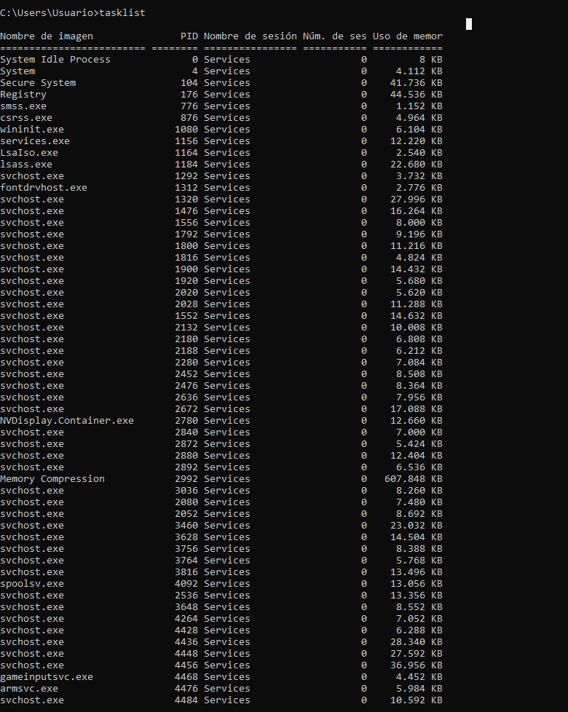

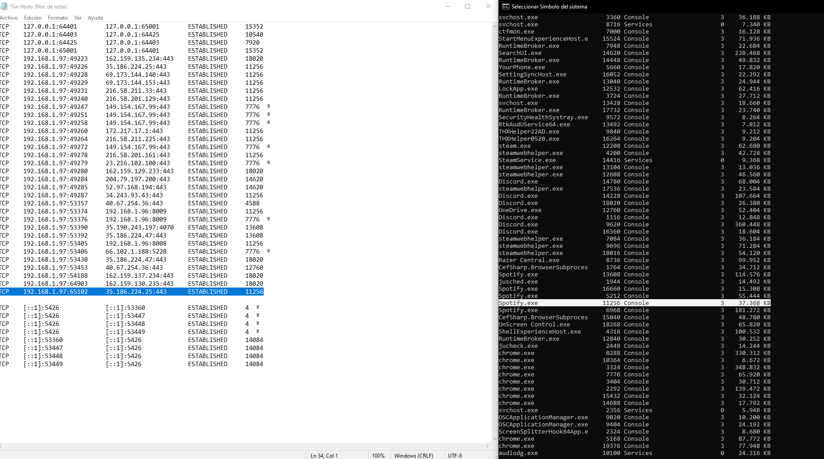
4- Buscamos el PID que habíamos apuntado para ver de que aplicación se trata como se puede ver en la imagen de abajo:

Mis PIDS serían de las siguientes aplicaciones, todas reconocidas:

TCP 127.0.0.1:64401 127.0.0.1:65001 ESTABLISHED 15352 -> nvcontainer.exe
TCP 127.0.0.1:64403 127.0.0.1:64425 ESTABLISHED 10540 -> NVIDIA Web Helper.exe
TCP 127.0.0.1:64425 127.0.0.1:64403 ESTABLISHED 7920 -> NVIDIA Share.exe
TCP 127.0.0.1:65001 127.0.0.1:64401 ESTABLISHED 15352 -> nvcontainer.exe
TCP 192.168.1.97:49223 162.159.135.234:443 ESTABLISHED 18020 -> Discord.exe
TCP 192.168.1.97:49226 35.186.224.25:443 ESTABLISHED 11256 -> Spotify.exe
TCP 192.168.1.97:49228 69.173.144.140:443 ESTABLISHED 11256 -> Spotify.exe
TCP 192.168.1.97:49229 69.173.144.153:443 ESTABLISHED 11256 -> Spotify.exe
TCP 192.168.1.97:49231 216.58.211.33:443 ESTABLISHED 11256 -> Spotify.exe
TCP 192.168.1.97:49240 216.58.201.129:443 ESTABLISHED 11256 -> Spotify.exe
TCP 192.168.1.97:49247 149.154.167.99:443 ESTABLISHED 7776 -> chrome.exe
TCP 192.168.1.97:49251 149.154.167.99:443 ESTABLISHED 7776 -> chrome.exe
TCP 192.168.1.97:49258 149.154.167.99:443 ESTABLISHED 7776 -> chrome.exe
TCP 192.168.1.97:49260 172.217.17.1:443 ESTABLISHED 11256 -> Spotify.exe
TCP 192.168.1.97:49264 216.58.211.225:443 ESTABLISHED 11256 -> Spotify.exe
TCP 192.168.1.97:49272 149.154.167.99:443 ESTABLISHED 7776 -> chrome.exe
TCP 192.168.1.97:49278 216.58.201.161:443 ESTABLISHED 11256 -> Spotify.exe
TCP 192.168.1.97:49279 23.216.102.100:443 ESTABLISHED 7776 -> Spotify.exe
TCP 192.168.1.97:49280 162.159.129.233:443 ESTABLISHED 18020 -> Discord.exe
TCP 192.168.1.97:49284 204.79.197.200:443 ESTABLISHED 14620 -> SearchUI.exe
TCP 192.168.1.97:49285 52.97.168.194:443 ESTABLISHED 14620 -> SearchUI.exe
TCP 192.168.1.97:49287 34.243.93.43:443 ESTABLISHED 11256 -> Spotify.exe
TCP 192.168.1.97:53357 40.67.254.36:443 ESTABLISHED 4588 -> svchost.exe
TCP 192.168.1.97:53374 192.168.1.96:8009 ESTABLISHED 11256 -> Spotify.exe
TCP 192.168.1.97:53376 192.168.1.96:8009 ESTABLISHED 7776 -> Spotify.exe
TCP 192.168.1.97:53390 35.190.243.197:4070 ESTABLISHED 13608 -> Spotify.exe
TCP 192.168.1.97:53392 35.186.224.47:443 ESTABLISHED 13608 -> Spotify.exe
TCP 192.168.1.97:53405 192.168.1.96:8008 ESTABLISHED 11256 -> Spotify.exe
TCP 192.168.1.97:53406 66.102.1.188:5228 ESTABLISHED 7776 -> Spotify.exe
TCP 192.168.1.97:53430 35.186.224.47:443 ESTABLISHED 18020 -> Discord.exe
TCP 192.168.1.97:53453 40.67.254.36:443 ESTABLISHED 12760 -> OneDrive.exe
TCP 192.168.1.97:54188 162.159.137.234:443 ESTABLISHED 18020 -> Discord.exe
TCP 192.168.1.97:64903 162.159.130.235:443 ESTABLISHED 18020 -> Discord.exe
TCP 192.168.1.97:65102 35.186.224.25:443 ESTABLISHED 11256 -> Spotify.exe

5- Yo no tengo ningún virus, pero si necesitáramos eliminar un virus al no reconocer una aplicación, se debería usar el comando: “taskkil /PID(numerodelpid) /F”

